**Exploring Cloud Structures: Unveiling Insights through Satellite Images**

**with EfficientUNetB5"**

|  |  |
| --- | --- |
| **HAMZA RAQEEB** | **21031287** |

**SUBMITTED BY:**

**INTRODUCTION**

play a crucial role in regulating solar radiation and managing the energy balance within the Earth's atmosphere. They have the ability to control the amount of radiation from the sun that reaches the surface, as well as the amount of radiation that is reflected back into space. The extent to which energy is retained within the planet directly impacts the atmospheric temperature, leading to phenomena such as the melting of polar ice caps and contributing to global warming. Conversely, a reduction in trapped energy results in cooler temperatures. By gaining a deeper understanding of cloud structures, climatologists can enhance their comprehension of the planet's weather patterns. Therefore, comprehending cloud structure holds immense significance for climatologists in their pursuit of scientific research [1]. The impact of climate change is influenced by various characteristics of cloud formations, including their shape, abundance, thickness, and altitude positioning. Different types of cloud structures exist, among which the top-level clouds known as Cirrus clouds are particularly prevalent. The term "Cirrus" derives from the Latin word for "curl of hair," emphasizing their distinctive appearance [2]. Cloud-induced updrafts and downdrafts have the potential to rapidly and unexpectedly impact the lift force acting upon aircraft wings, leading to turbulence. This turbulence can result in erratic movements and instability during flight, posing a challenge for less experienced pilots who may struggle to maintain control of the aircraft. The consequences can be problematic and pose safety risks. In contrast, the operations of cargo ships heavily rely on the unpredictable and ever-changing weather conditions at sea. These weather patterns can significantly impact shipping schedules, causing delays that translate into substantial financial losses, particularly in terms of fuel consumption, amounting to hundreds of thousands of dollars. Additionally, storms further exacerbate shipping delays, contributing to multimillion-dollar losses. Early prediction and detection of storms or weather changes play a pivotal role in saving lives and preventing significant financial losses. Remote sensing or satellite imagery is a critical component in various fields, including environmental monitoring, disaster response, and law enforcement. One significant application of satellite imagery involves the detection and classification of objects and facilities using deep learning techniques.

**Related Work**

Pritt et al. proposed a method that utilizes satellite images from the IARPA Functional Map of the World (fMoW) dataset to classify these objects and facilities into 63 distinct classes. Pritt et al [3] The researchers put forward a system that combines multiple convolutional neural networks along with additional neural networks to incorporate satellite metadata and image features. This ensemble-based approach demonstrated commendable accuracy in classifying objects and facilities in satellite imagery. Laban et al. [4] The researchers introduced a novel approach for satellite image classification by leveraging convolutional neural networks (CNNs), acknowledging the growing significance of remote sensing in practical applications. They employed cutting-edge models and discovered that their proposed model outperformed others in terms of classification accuracy. The success of their model was attributed to the careful selection of an appropriate image scale, ensuring effective performance in the classification task. Esch et al. [5] Employed diverse remotely sensed data to develop an optimization approach using Defines Developer software. The objective was to enhance the quality of image segmentation by minimizing both over-segmentation and under-segmentation errors, ultimately achieving more precise segmentation results. Their proposed method yielded a notable improvement of 20-40% in object accuracy. Extracting a matte is a valuable technique for isolating foreground objects from the background in static images. It involves determining the pixel coverages, both full and partial, thereby allowing for the extraction of features from images with limited information and noise. This approach proves particularly useful in scenarios where image quality is compromised. Wang et al. [6] presented a novel approach by combining the challenges of segmentation and matting in remote sensing images. Their proposed unified optimization approach, leveraging Belief Propagation, aimed to address the limitations of traditional shallow algorithms that struggle with feature extraction from remote sensing images. These challenges often lead to low accuracy when detecting snow and cloud images.

**DATASET** The goal is to analyze satellite images and differentiate various types of cloud formations, classifying them as Fish, Flower, Gravel, or Sugar. The competition utilized images sourced from NASA Worldview, covering three specific regions measuring 21 degrees in longitude and 14 degrees in latitude. The true-color images provided are captured by the TERRA and AQUA satellites, which pass over each region once per day [7]. Occasionally, images may be created by merging data from two satellite orbits, and any areas not covered by these merged images are represented as black.

**EXPLORATORY ANALYSIS OF DATASET**

To get an in-depth understanding of the data for my exploratory study of the "Understanding Clouds from Satellite Images" dataset for my dissertation. This required evaluating the dataset's composition, size, and organization. I first looked through the data, counting the samples and variables and looking for any missing values. I also looked at the distribution of the data to look for any probable outliers or skewed trends. I used visualization tools including histograms, and scatter plots, shown in, to explore the dataset's variables, such as cloud kinds, image attributes, and metadata, in order to obtain insights into the interactions, correlations, and dependencies between the variables. Shown in Fig.1, and Fig.2. In order to check more exploratory analysis, check the google colab link attached.

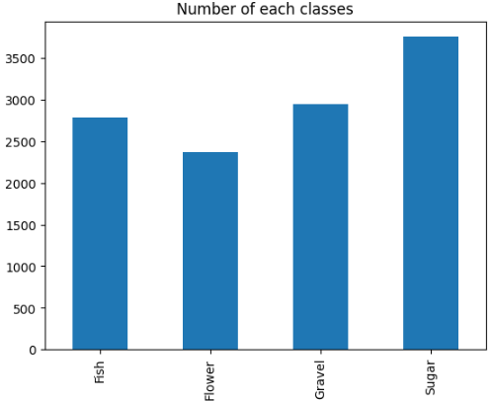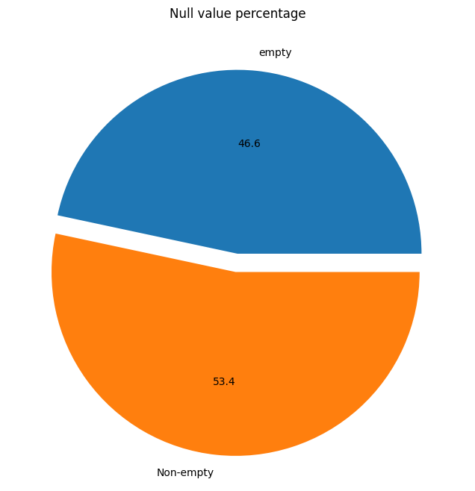

Fig.2 shows the Null Value Percentage. Fig.3 Shows the Number of Values in class.

**Segmenting Regions of Images**

Segmenting regions involves partitioning an image or dataset into separate and meaningful segments based on specific criteria like color, texture, or shape. This technique entails grouping together pixels or data points that exhibit similar characteristics. By segmenting regions, it becomes possible to focus on individual areas within the image or dataset, facilitating tasks like recognizing objects, segmenting images, and detecting patterns [8]. Fig.4 Shows images segmenting regions.

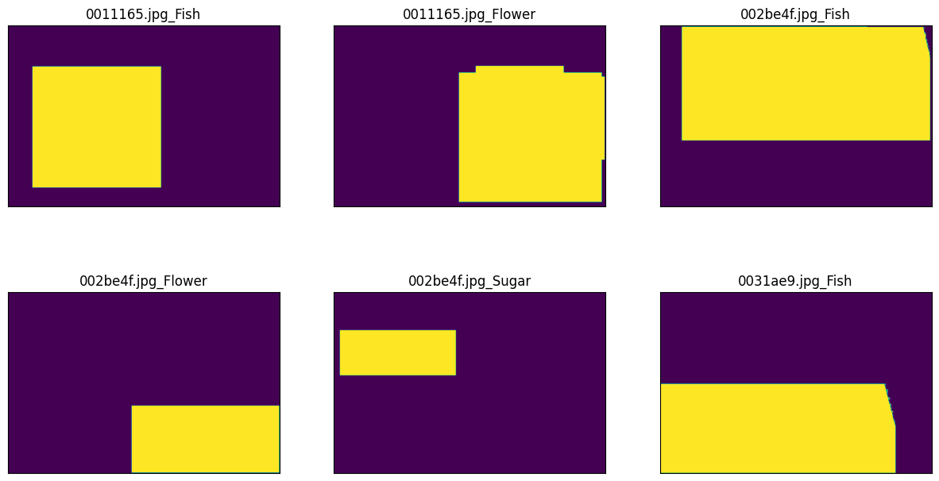

Fig.4 Shows images segmenting regions.

**Sample image with masks overlayed**

Sample images are often accompanied by corresponding masks that indicate the labeled regions of interest, such as specific cloud types or boundaries. Fig.5 shows the masksoverlayed. These masks are typically overlaid on the original images to visually highlight and differentiate the target areas for analysis or classification purposes.

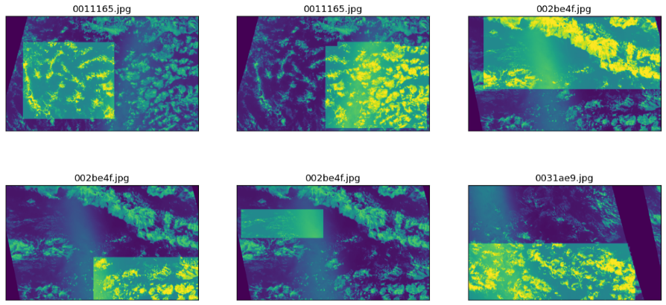

Fig.5 Shows a Sample image with masks overlayed

**Model EfficientNet-B5:** EfficientNet-B5, a variant of the EfficientNet CNN architecture family, stands out for its remarkable efficiency and high performance in image recognition tasks. With increased depth and wider feature maps compared to earlier versions, EfficientNet-B5 achieves a balance between accuracy and computational efficiency through innovative methods such as compound scaling and neural architecture search. This architecture has gained extensive popularity in computer vision applications, showcasing exceptional results in image classification, object detection, and semantic segmentation tasks [9].

**Adam Optimizer:** is a widely adopted optimization algorithm utilized in deep learning and machine learning. It stands for "Adaptive Moment Estimation" and integrates the benefits of AdaGrad and RMSProp methods. By considering past gradients and their squared gradients, Adam dynamically adapts the learning rate for each parameter, facilitating quicker convergence in the training process [10]. This algorithm's popularity stems from its ability to efficiently adjust the learning rate, leading to enhanced training performance in various machine learning tasks.

**Activation Function:** A sigmoid activation function is widely utilized in machine learning and neural networks due to its effectiveness. It maps input values to a range between 0 and 1, which aids in compressing the output. This activation function finds particular applications in binary classification tasks, where the objective is to predict between two classes.

|  |  |
| --- | --- |
| **Loss:** | 0.8482153415679932 |
| **IoU:** | 0.3933699429035187 |
| **F1:** | 0.5451632142066956 |

**Table.1 Shows Model Accuracy**

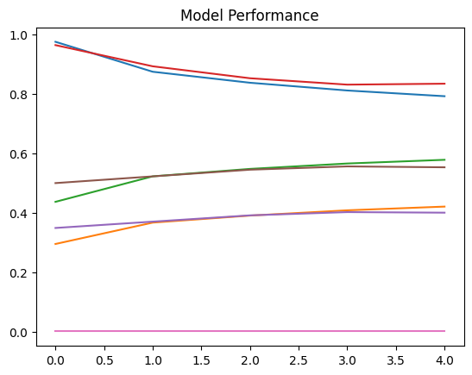

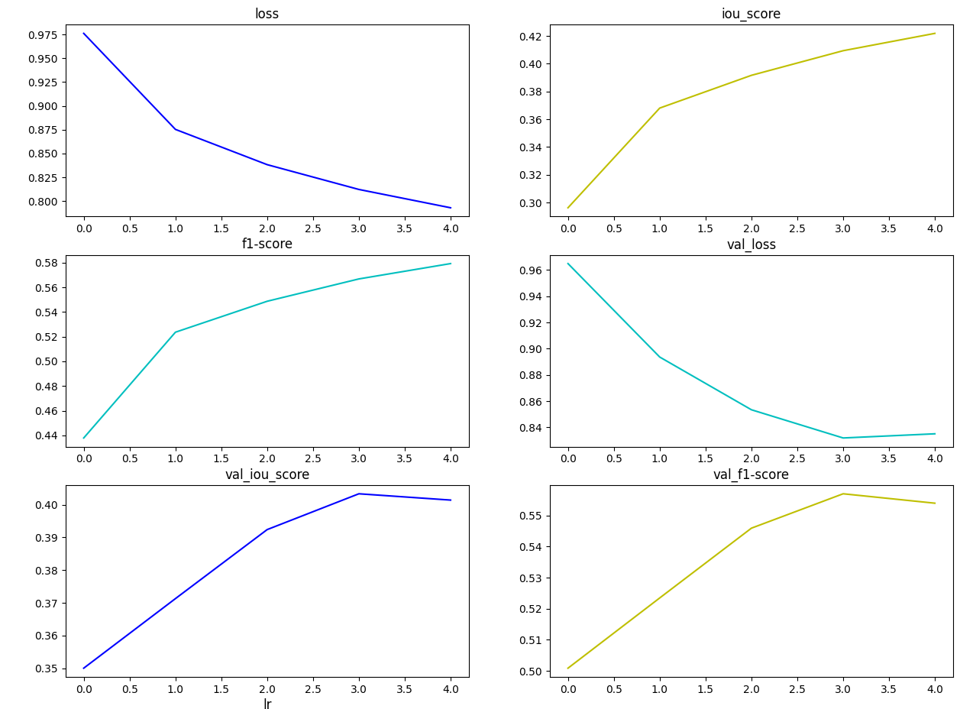

**Actual Images And Their Predicted Result** In the context of the "Understanding Clouds from Satellite Images" dataset, images are often accompanied by their corresponding predicted results. These predicted results are generated through the application of machine learning models trained on the dataset.

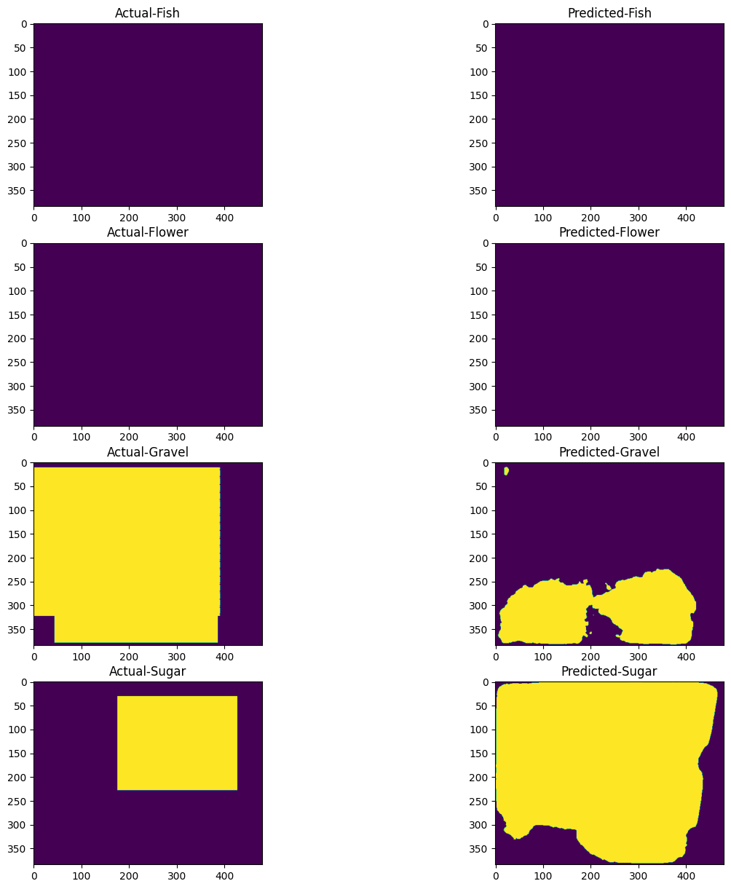

**Critical Analysis of My Assignment**

The results obtained from your EfficientNet-B5 model for the cloud formation classification task indicate that there is still room for improvement. The loss value of 0.848 suggests the need to minimize the discrepancy between predicted and actual outputs. The IoU score of 0.393 highlights the need to enhance the model's ability to accurately localize and segment cloud types. Furthermore, the F1 score of 0.545 indicates the requirement for better differentiation between different cloud categories. To enhance the model's performance, it is recommended to explore adjustments in the model architecture, hyperparameters, training epochs, and data augmentation techniques. It is crucial to consider the dataset's characteristics, task complexity, and available computational resources. Further experimentation and refinement are advised to achieve improved results.

**Future Work of My Assignment**

In the future, the assignment project titled "Exploring Cloud Structures: Unveiling Insights through Satellite Images with EfficientUNetB5" aims to integrate transformer-based models to enhance the analysis of cloud structures. By harnessing the capabilities of transformers, the project seeks to deepen our understanding of intricate cloud formations and extract valuable information from satellite imagery. Additionally, the team intends to implement specific pre-processing techniques to improve the quality of the input data, including tasks such as reducing noise, enhancing images, and extracting important features. Furthermore, the project will prioritize the development of advanced methods to accurately pinpoint the precise locations of cloud structures in satellite images, facilitating more accurate analysis and interpretation. These advancements will greatly contribute to advancing our comprehension of cloud formations, their impact on weather patterns, climate studies, and various applications within the field of satellite imagery analysis.

**Google Colab Link:**

[**https://colab.research.google.com/drive/1cn_jpGMHh-g8NBqDAwI8BhCRZFK71y1n?usp=sharing**](https://colab.research.google.com/drive/1cn_jpGMHh-g8NBqDAwI8BhCRZFK71y1n?usp=sharing)

**GitHub Link:** https://github.com/HHamaz123/Assignment-on-dataset

**References:**

1. Turner, D. D., Vogelmann, A. M., Austin, R. T., Barnard, J. C., Cady-Pereira, K., Chiu, J. C., ... & Wiscombe, W. (2007). Thin liquid water clouds: Their importance and our challenge. *Bulletin of the American Meteorological Society*, *88*(2), 177-190.
2. Dowling, D. R., & Radke, L. F. (1990). A summary of the physical properties of cirrus clouds. *Journal of Applied Meteorology and Climatology*, *29*(9), 970-978.
3. Pritt, M., & Chern, G. (2017, October). Satellite image classification with deep learning. In *2017 IEEE applied imagery pattern recognition workshop (AIPR)* (pp. 1-7). IEEE.
4. Laban, N., Abdellatif, B., Ebied, H. M., Shedeed, H. A., & Tolba, M. F. (2020). Multiscale satellite image classification using deep learning approach. *Machine Learning and Data Mining in Aerospace Technology*, 165-186.
5. Esch, T., Thiel, M., Bock, M., Roth, A., & Dech, S. (2008). Improvement of image segmentation accuracy based on multiscale optimization procedure. *IEEE Geoscience and Remote Sensing Letters*, *5*(3), 463-467.
6. Wang, J., & Cohen, M. F. (2005, October). An iterative optimization approach for unified image segmentation and matting. In *Tenth IEEE International Conference on Computer Vision (ICCV'05) Volume 1* (Vol. 2, pp. 936-943). IEEE.
7. Ahmed, T., & Sabab, N. H. N. (2022). Classification and understanding of cloud structures via satellite images with EfficientUNet. *SN Computer Science*, *3*, 1-11.
8. Blaschke, T., Burnett, C., & Pekkarinen, A. (2004). Image segmentation methods for object-based analysis and classification. In *Remote sensing image analysis: Including the spatial domain* (pp. 211-236). Dordrecht: Springer Netherlands
9. Maswood, M. M. S., Hussain, T., Khan, M. B., Islam, M. T., & Alharbi, A. G. (2020, November). Cnn based detection of the severity of diabetic retinopathy from the fundus photography using efficientnet-b5. In *2020 11th IEEE Annual Information Technology, Electronics and Mobile Communication Conference (IEMCON)* (pp. 0147-0150). IEEE.
10. Vani, S., & Rao, T. M. (2019, April). An experimental approach towards the performance assessment of various optimizers on convolutional neural network. In *2019 3rd international conference on trends in electronics and informatics (ICOEI)* (pp. 331-336). IEEE.